Technical Design Document

Team: | DevMafia | Project ID(s): | DEVACDMY-5142
Feature Number(s): |  | Pipeline(s):

1.0 Introduction 2
1.1 Link to Requirements Document 2
2.0 Design Discussion 2
2.1 Architecture 2
2.2 Phases 4
2.3 Reusable Components/Code 4
3.0 Implementation Details 4
4.0 Development Process Guidelines 4
5.0 Testing Considerations 5
6.0 Sample Screenshots 6
7.0 Outstanding Questions Related to Design 9

Introduction
This is a Web Based Template Editor which helps in generating custom Reference Templates based on User’s requirements.
It takes input from the User and creates appropriate sections which will hold data for further processing.
This is an enhancement over Manual Entry and creation of templates, thereby saving time.

Link to Requirements Document
https://jira2.cerner.com/browse/DEVACDMY-5142

Design Discussion

Architecture
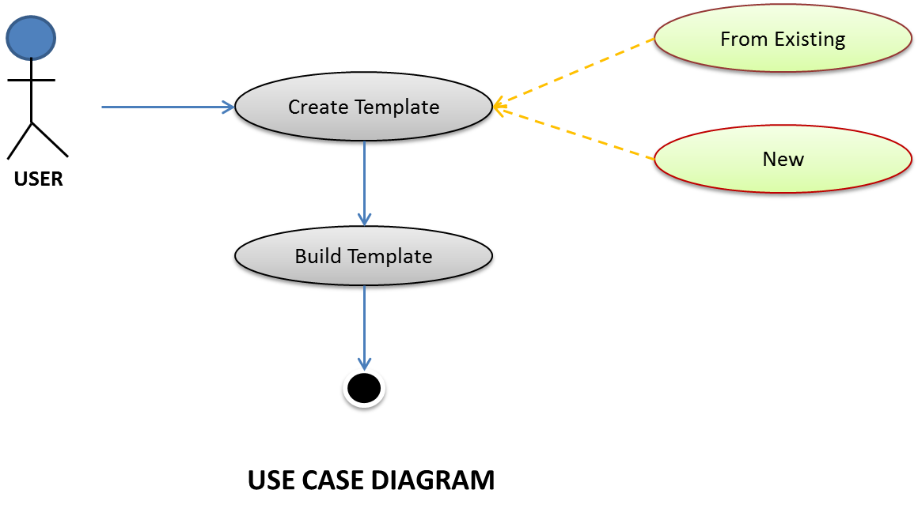

Flow Diagram:

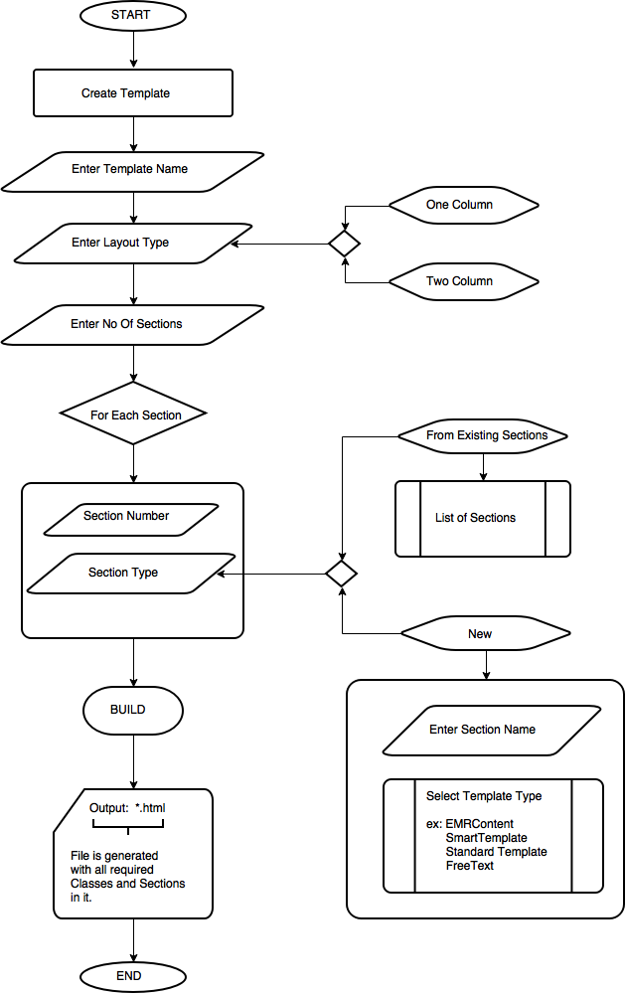

Phases
List and briefly describe the implementation phases detailed in Section 3.

Reusable Components/Code
Nothing yet

Implementation Details

This project is to build web based template editor which will be in HTML format by using the existing HTML reference template. To build these template, we are using HTML, JavaScript, Jquery, Bootstrap, Json concepts. The Template includes some of the fields like Name of the Template, Type of layouts, Number of sections etc. User need to select type of layout, based on that they can select number of sections required which will populate data dynamically using Json and depend on the sections, the list of sections will display which is of type hyperlink. When user selects particular section hyperlink, popup page will be displayed, which contains Existing and New sections details. When user selects Existing Templates, the corresponding attributes of the template should be displayed and if user selects New section, then details need to be entered by the user to build the particular section. After saving the existing/New template details, the hyperlink button should change to its corresponding template name. Finally by using build section button, online web based template editor will be generated.

Development Process Guidelines
We will be building static pages first and then make them responsive pages using JQuery/JavaScript.
Next, we will fetch the data from Json file to display data dynamically.
Next, we will be working with dummy JSON values and check for its correctness and integrity.
Finally, we will implement the backend API to work on a part of actual data and do regression testing on it.

4.1 Brief information about the Template:

Besides general HTML Tags and definitions, the template generated will be in sections and sub sections with custom classes which are pre-defined in xml or json file.

A Section will be the main container holding other sub sections and divisions, which will hold data in it. A section will be defined with class: ddsection and contain other classes like ddrefreshable, ddinsertfreetext, ddremovable.
Each section will have a unique attributes like dd:sectioncode, dd:referenceuuid for content type.

A Sub Section is a placeholder inside Section, and will be holding other divisions. A Subsection is defined by class: ddsubsection and contains attributes ddcontenttype and dd:referenceuuid and ddfreetext etc.

All Sections and subsection are labeled using SPAN tags.

Testing Considerations

#Test Cases | Test Steps | Expected Results
TC 1 | Enter a Valid String for Template Name | The input, if valid should be accepted else a suggestion will pop up asking to check for illegal characters.
TC 2 | Select options from the drop down list for Template Layout Type | If no option is selected, User will be prompted to select either of the options available from the drop down list.
TC 3 | Select options from the drop down list for Number of Sections | If no option is selected, User will be prompted to select a number from the options available from the drop down list.
TC 4 | Build Template | All fields are mandatory and the output should be in HTML format, containing the appropriate classes and sections.

Sample Screen Shots:
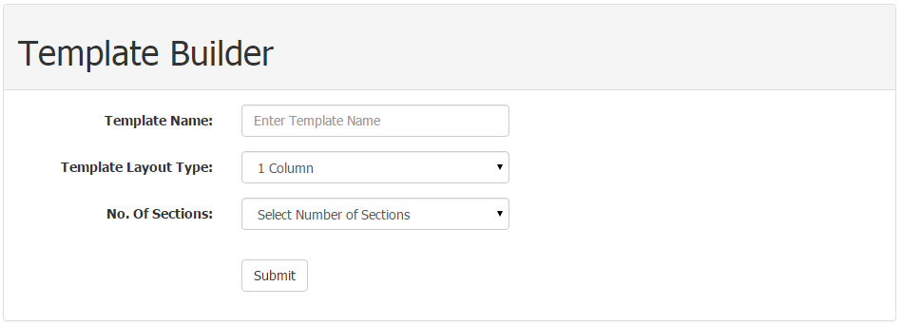
Fig 6.0.1: Main Page

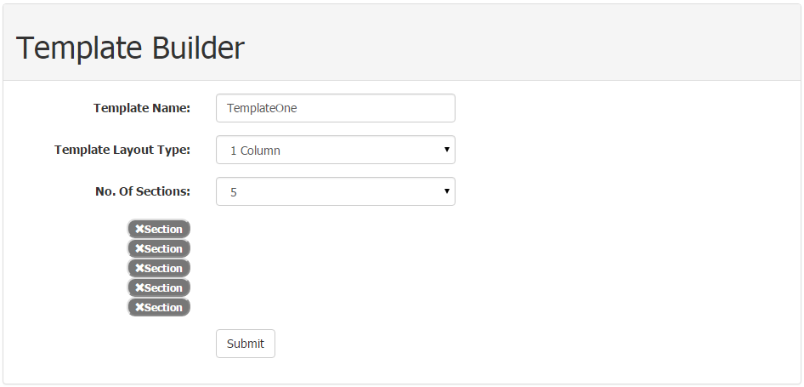
Fig 6.0.2: Single Layout Column

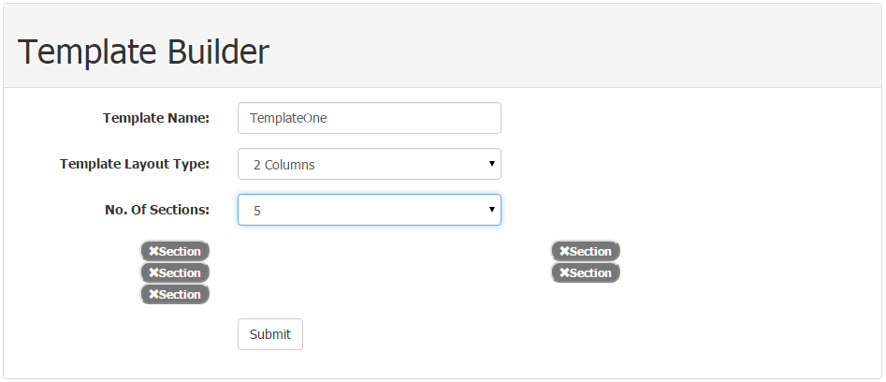

Fig 6.0.3: Double Layout Column

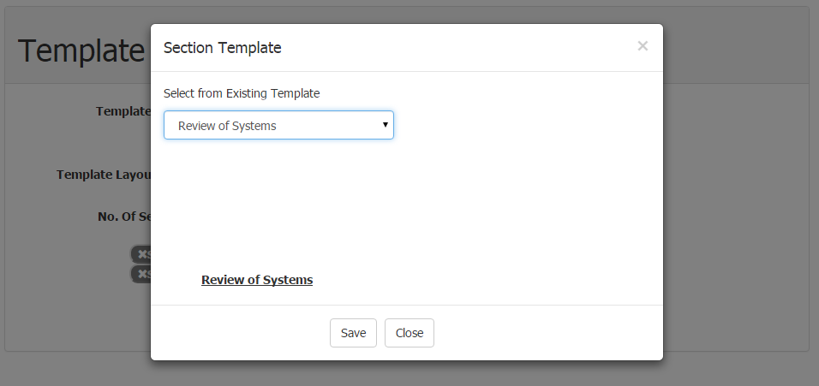

Fig 6.0.4: Existing Template Creation Page

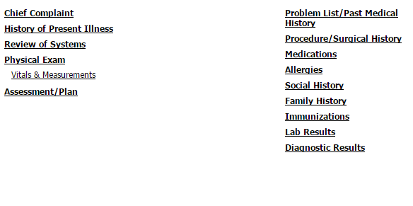
Fig 6.0.5: Two Column Output

Outstanding Questions Related to Design

Revision History

REVISION | DATE | NAME | DESCRIPTION OF CHANGE
1 | 05/08/2015 | Suneel and Sreehari | Initial release
2 | 06/08/2015 | Suneel and Sreehari | Updating with screenshots and test cases
3 | 12/08/2015 | Suneel and Sreehari | Updated implementation details
4 | 18/08/2015 | Suneel and Sreeehari | Updated Implementation details and Screenshots.

